TREATMENT OF RAYNAUD’S PHENOMENON AND BLOOD CIRCULATION PROBLEMS WITH STEM CELLS FROM FAT

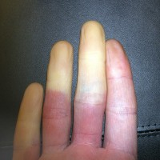 In a recently published clinical study from Marseille 12 patients with circulation problems in the hands (Raynaud’s disease)underwent promising treatment with the body’s own (autologous) stem cells. The pale fingers are caused by the reduced blood flow. The circulation problems were triggered by the connective tissue disease scleroderma, which is considered an autoimmune disease. Women are affected five times more frequently than men.
In the study a suspension of autologous stem cells (Stromal Vascular Fraction, SVF) was injected into the patient’s fingers. The stem cell suspension was obtained from a small amount of fat was harvested by liposuction. No side effects were recorded during the treatments, all patients showed an improvement in symptoms. Here we see once again how the aesthetic surgery enhances therapeutic medicine.
In my clinic we have treated cases of scleroderma and other autoimmune diseases successfully. Among them was a patient with scleroderma who especially suffered under the parchment-like skin on her hands caused by the disease. In many patients suffering from scleroderma – apart from disturbed blood flow – the skin’s appearance changes, which can often be improved by stem cell injections. Additional intravenous infusions of autologous stem cells should be made in scleroderma because in systemic autoimmune diseases systemic application is important.
This is very good news for affected patients and their doctors.

